EVERY QUESTION MUST BE READ CAREFULLY AND ANSWER WHAT IS ASKED. PLEASE USE APA FORMAT (IN TEXT CITATION AND THE WORK CITED AT THE END OF THE PARAGRAPH). HIGHLIGHT THE QUESTIONS THAT ARE BEING ASKED AND RESPOND RIGHT UNDER IT IN A PARAGRAPH FORM. ONE TO TWO CITATIONS MINIMUM (NO MORE THAN 4 IF NEEDED). EVERYTHING IS WRITTEN CLEARLY. I REPEAT, EVERY QUESTION SHOULD BE WITH A CITATION.
EVERY QUESTION SHOULD BE ANSWERED THOUROUGHLY AND DETAILED. DO NOT ANSWER BACK WITH A FEW SENTENCES.

- How does the focus of research and evidence-based practice (EBP) differ? Discuss the application of research findings into evidence-based nursing practice. Provide an example.

- Why is it important to conduct a quality literature review? Characterize the four major types of reviews. What are the essential components of a quality literature review?

- What are some research designs that justify themselves in the field of nursing research? Choose one and explain why you chose it. Give an example of how this research design is used in your nursing discipline.

- Select one qualitative and one quantitative question that you are interested in investigating. Identify the independent and dependent variables. Next, create a hypothesis or set of hypotheses to go along with your research question. Identify your hypothesis as one of each of the four categories below and explain why your hypothesis fits into these categories (hint: review chapter 3).
- Associative or causal
- Simple or complex
- Nondirectional vs. directional
- Null vs. research

Book: Evidence-Based Practice for Nurses: Appraisal and Application of Research Author: Schmidt, N., & Brown J.
Publisher: Jones & Bartlett Learning
Edition: 4th (2018) or 3rd

- Visit the Healthy People 2020 website, Topics and Objectives page https://www.healthypeople.gov/2020/topics-objectives and explore some topics. Discuss how epidemiological methods are used to evaluate Healthy People 2020 objectives. Provide examples.
LINK: https://www.healthypeople.gov/2020/topics-objectives
- What is the difference between qualitative and quantitative research sampling strategies? Compare and contrast the strategies and describe some of the advantages and disadvantages of each.
- Discuss characteristics used to appraise when evaluating qualitative and quantitative designs. Which characteristics are the most important and why?
- How is data used to evaluate outcomes? Provide an example that relates to an area of nursing.
- Conducting research with strong ethical principles is a critical component of being an effective nurse researcher. In the research simulation activity, which character(s) did you play? What did you learn about ethical principles in research? Are ethics in research clear cut, or do you think there are some gray areas?

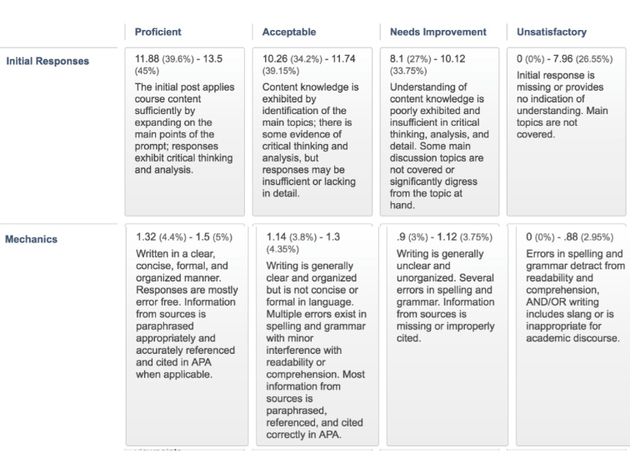
MAKE SURE YOU FOLLOW THE RUBRIC:

